## **Objectives**

* Explain React State

In this hands-on lab, you will learn how to:

* Use React State object

## **Prerequisites**

The following is required to complete this hands-on lab:

* Node.js
* NPM
* Visual Studio Code

## **Notes**

Estimated time to complete this lab: **60 minutes.**

Create a React App “counterapp” which will have a component named “CountPeople” which will have 2 methods.

UpdateEntry() 🡪 which will display the number of people who entered the mall.

UpdateExit() 🡪 which will display the number of people who exited the mall.

Use Constructor and state to Store the entrycount and exitcount.

The component has 2 buttons

1. Login 🡪 when clicked, the entrycount should get incremented by 1
2. Exit 🡪 when clicked, the exitcount should get incremented by 1

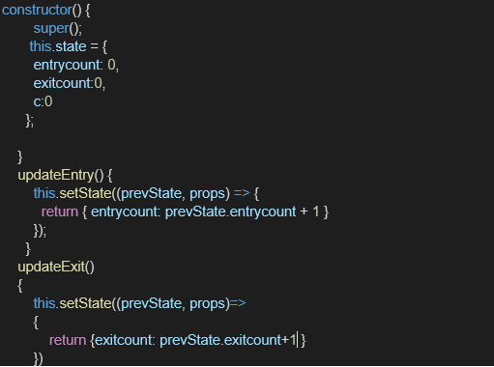

The output should be as follows:

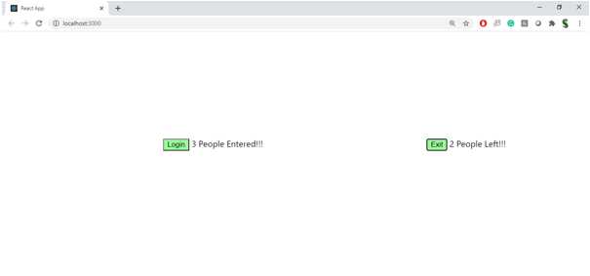

CountPeople.js

import React, { Component } from 'react';

class CountPeople extends Component {

  constructor(props) {

    super(props);

    this.state = {

      entryCount: 0,

      exitCount: 0

    };

  }

  updateEntry = () => {

    this.setState((prevState) => ({

      entryCount: prevState.entryCount + 1

    }));

  };

  updateExit = () => {

    this.setState((prevState) => ({

      exitCount: prevState.exitCount + 1

    }));

  };

  render() {

    return (

      <div style={styles.container}>

        <h1>Mall Entry Counter</h1>

        <p><strong>People Entered:</strong> {this.state.entryCount}</p>

        <p><strong>People Exited:</strong> {this.state.exitCount}</p>

        <button style={styles.button} onClick={this.updateEntry}>Login</button>

        <button style={styles.button} onClick={this.updateExit}>Exit</button>

      </div>

    );

  }

}

const styles = {

  container: {

    textAlign: 'center',

    marginTop: '50px',

    fontFamily: 'Arial'

  },

  button: {

    margin: '10px',

    padding: '10px 20px',

    fontSize: '16px'

  }

};

export default CountPeople;

